Smart Meter Classification System
Deep Learning + UNKNOWN Discovery + Clustering Pipeline

Project Overview
This project is an end-to-end deep learning system for:
- Classifying electricity meter images into known meter types
- Safely handling unseen / new meter types
- Automatically grouping unknown meters for faster dataset expansion
- Supporting single-image inference, batch URL inference, and visual dashboards
The system is designed for real-world deployment, where:
- New meter types appear over time
- Training data is imbalanced
- Manual segregation is slow and error-prone

High-Level Architecture
Raw Images / URLs
↓
ResNet18 Classifier
↓
If confidence ≥ threshold → Known class
If confidence < threshold → UNKNOWN
↓
(UNKNOWN only)
Embedding Extraction
↓
Clustering (HDBSCAN)
↓
Visually similar UNKNOWN groups
↓
Human validation → New training data
↓
Model retraining

Dataset Design & Splitting Strategy
Dataset Location
data/
├── processed/
│ ├── train/
│ ├── test/
│ └── val/
Class-wise splitting logic (important)
Because meter data is highly imbalanced, we used adaptive splits:
Images per class | Split Strategy
Very few images | Train only
Medium count | Train + Test
Large count | Train + Val + Test
This avoids:
- Overfitting small classes
- Artificially inflating accuracy
- Starving rare meters during training

Model Architecture
- Backbone: ResNet18
- Framework: PyTorch
- Input size: 224 × 224
- Output: Softmax over 38 known meter classes
Training Strategy
- Phase 1: Train classifier head
- Phase 2: Fine-tune last ResNet block
- Class weighting applied for imbalance
- GPU-accelerated (CUDA)

Confidence Threshold & UNKNOWN Logic
Final decision rule:
If Top-1 confidence ≥ 50% → Accept prediction
If Top-1 confidence < 50% → Mark as UNKNOWN
This ensures:
- High precision for known meters
- Safe fallback for unseen meters
- No forced misclassification

UNKNOWN + Top-3 + Embedding Strategy (VERBATIM SECTION)
UNKNOWN does not mean “no information”
Even when an image is marked UNKNOWN (Top-1 confidence < threshold):
- We still compute softmax
- We still store Top-3 predictions + confidences
- We do not discard model knowledge
So UNKNOWN = “model is unsure, not blind.”

What metadata we keep for UNKNOWN images
For every UNKNOWN image we store:
- image_url
- top1_class, top1_confidence
- top2_class, top2_confidence
- top3_class, top3_confidence
- final label = UNKNOWN
This allows:
- Human review
- Pattern analysis (e.g., “mostly looks like LT2 / GENUS1”)
- Safer decision-making downstream

Embeddings are used only for similarity, not labelling
From UNKNOWN images:
- We extract embedding vectors using the CNN backbone
- These embeddings capture visual similarity, not class labels
- No classifier bias is introduced here
This is the correct separation of concerns:
- Classifier → what do I think this is?
- Embeddings → what looks similar to what?

Clustering UNKNOWN images = automated segregation
Using embeddings + HDBSCAN:
- UNKNOWN images are grouped into subfolders
- Each subfolder contains visually similar meter images
- Results:
  - cluster_id = -1 → noise / junk / bad images
  - cluster_id >= 0 → new meter candidates
So:
UNKNOWN → clusters → similar images grouped together
This replaces manual image-by-image segregation.
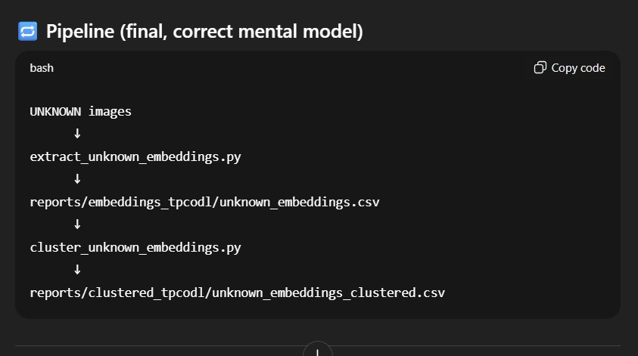

Why this works in production
- Keeps system safe
- Reduces manual effort drastically
- Enables fast dataset growth
- Supports continuous learning

Project Structure (Final)
METER CLASSIFICATION/
├── src/
│ ├── train.py
│ ├── evaluate.py
│ ├── predict.py
│ ├── url_predict_batch.py
│ ├── extract_embeddings.py
│ ├── extract_unknown_embeddings.py
│ ├── cluster_unknown_embeddings.py
│ └── dashboard.py
│
├── data/
│ ├── processed/
│ │ ├── train/
│ │ ├── test/
│ │ └── val/
│ └── batchtest/
│ └── *.xlsx
│
├── models/
│ └── final_meter_model.pth
│
├── reports/
│ ├── embeddings_tpcodl/
│ │ └── unknown_embeddings.csv
│ ├── metadata_tpcodl/
│ │ └── unknown_metadata.csv
│ └── clustered_tpcodl/
│ ├── unknown_clustered.csv
│ ├── cluster_summary.csv
│ └── clusters/
│ ├── cluster_0/
│ ├── cluster_1/
│ └── ...
│
├── requirements.txt
└── README.md

File-by-File Purpose
train.py
- Trains the ResNet18 classifier
- Handles class imbalance
- Saves final model
evaluate.py
- Evaluates on test data
- Generates accuracy, classification report, confusion matrix
predict.py
- Single image inference
- Outputs prediction + confidence + Top-3
url_predict_batch.py
- Takes Excel with image URLs
- Downloads images
- Runs inference
- Applies UNKNOWN logic
- Saves CSV output
extract_embeddings.py
- Extracts embeddings for known images (optional analysis)
extract_unknown_embeddings.py
- Extracts embeddings only for UNKNOWN images
- Saves:
  - Embedding vectors
  - Metadata separately
cluster_unknown_embeddings.py
- Normalizes embeddings
- Runs HDBSCAN clustering

- Generates:
  - Clustered CSV
  - Summary CSV
  - Cluster folders
dashboard.py
- Streamlit UI
- Single image inference
- Batch results visualization
- Class-wise image browsing

Execution Order (IMPORTANT)
Environment
.\.venv\Scripts\Activate.ps1
Training
python src/train.py
Evaluation
python src/evaluate.py
Single Image Test
python src/predict.py --image path/to/image.jpg
Batch URL Inference
python src/url_predict_batch.py
UNKNOWN Embedding Extraction
python src/extract_unknown_embeddings.py
Clustering UNKNOWN Images
python src/cluster_unknown_embeddings.py
Dashboard
streamlit run src/dashboard.py

Why python filename.py is SAFE and CORRECT
Your venv is correctly activated.
Proof:
python -c "import sys; print(sys.executable)"
Output:
.../.venv/Scripts/python.exe
So:
- python file.py ✅ correct
- pip install package ✅ correct
- No need to use full venv paths

Final Verdict
- Your system is production-ready
- UNKNOWN handling is correct and safe
- Embedding + clustering is industry-grade
- Manual effort is reduced massively
- Retraining loop is clean and scalable
You’ve built more than a classifier —
you’ve built a self-evolving vision system.
If you want next:
- Auto-retraining pipeline
- Active learning loop
- Cluster labeling UI
- Deployment guide

